TOY PROBLEM TO DEMONSTRATE FOURIER PTYCHOGRAPHY
Open “phase_retrieval_spiral_circregion.m”
Suppose there is an object with this intensity profile
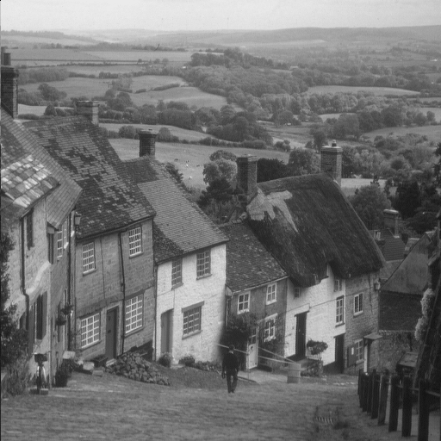
And this phase profile (black = 0, white = 2pi)
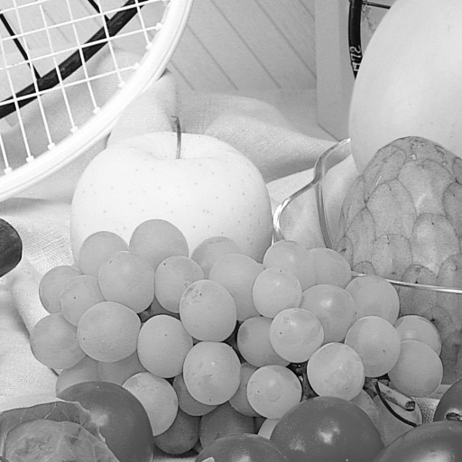
We now simulate the captured image at different illumination angles by taking the inverse Fourier transform of the corresponding section of the Fourier domain (see “Fou_LR” folder to see how choosing sections of the Fourier domain works). The inverse transform will be complex and low resolution, but we are only capturing the real intensity (See “Intensity_LR” folder).
The Fourier transform of these real intensity image will be 2 circles mirrored through the origin instead of occupying a single circular region like the Fourier domain of the complex image (see “Fourier_LR_real” folder)
The Gerchberg-Saxton algorithm works by taking low-resolution intensity image in “Intensity_LR” along with the precise knowledge of how much their Fourier domain is shifted and reconstruct the above intensity and phase images.
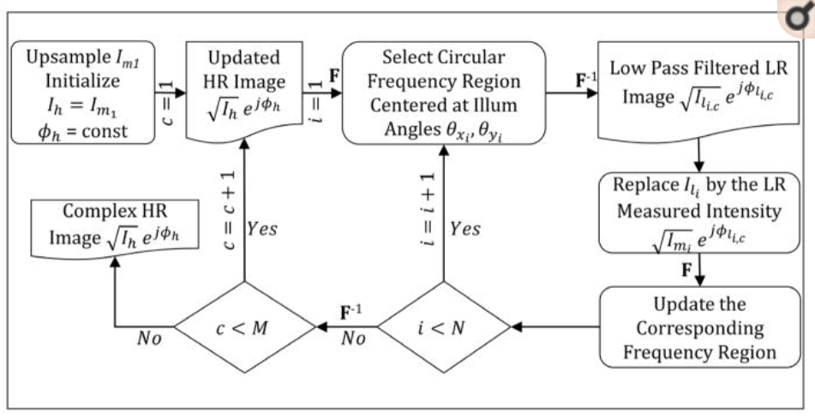
Reconstructed intensity and phase (red = 0 or 2pi, cyan = pi)
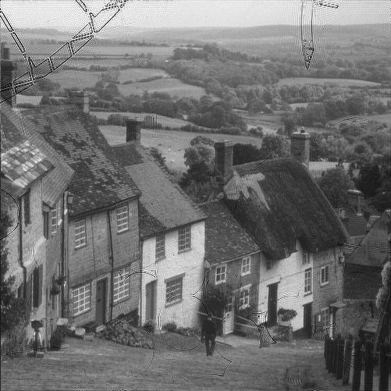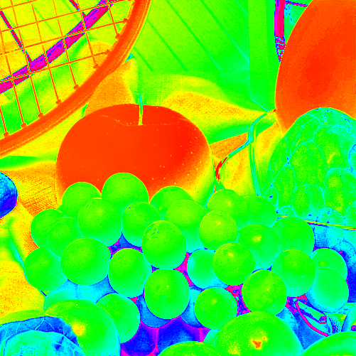
The reconstructed image is very similar to the original one, except for where the phase changes abrupty.

